- 入门算法
1.
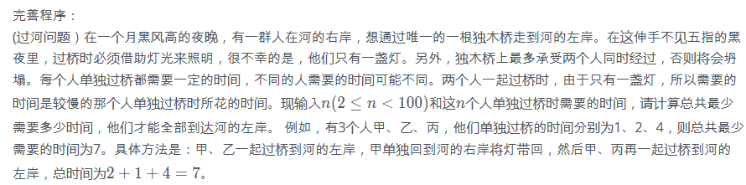
#include <iostream>
using namespace std;

const int SIZE = 100;
const int INFINITY = 10000;
const bool LEFT = true;
const bool RIGHT = false;
const bool LEFT_TO_RIGHT = true;
const bool RIGHT_TO_LEFT = false;

int n, hour[SIZE];
bool pos[SIZE];

int max(int a, int b)
{
if (a > b)
return a;
else
return b;
}

int go(bool stage)
{
int i, j, num, tmp, ans;
if (stage == RIGHT_TO_LEFT) {
num = 0;
ans = 0;
for (i = 1; i <= n; i++)
if (pos[i] == RIGHT) {
num++;
if (hour[i] > ans)
ans = hour[i];
}
if ([ ① ])
return ans;
ans = INFINITY;
for (i = 1; i <= n - 1; i++)
if (pos[i] == RIGHT)
for (j = i + 1; j <= n; j++)
if (pos[j] == RIGHT) {
pos[i] = LEFT;
pos[j] = LEFT;
tmp = max(hour[i], hour[j]) +[ ② ];
if (tmp < ans)
ans = tmp;
pos[i] = RIGHT;
pos[j] = RIGHT;
}
return ans;
}
if (stage == LEFT_TO_RIGHT) {
ans = INFINITY;
for (i = 1; i <= n; i++)
if ([ ③ ]) {
pos[i] = RIGHT;
tmp =[ ④ ];
if (tmp < ans)
ans = tmp;
[ ⑤ ];
}
return ans;
}
return 0;
}

int main()
{
int i;

cin>>n;
for (i = 1; i <=n; i++) {
cin>>hour[i];
pos[i] = RIGHT;
}
cout<<go(RIGHT_TO_LEFT)<<endl;
return 0;
}

2.阅读程序写结果
#include<iostream>
#include<cstring>
using namespace std;

const int SIZE = 100;

int main()
{
int n,i,sum,x,a[SIZE];

cin>>n;
memset(a,0,sizeof(a));

for(i=1;i<=n;i++){
cin>>x;
a[x]++;
}
i=0;
sum=0;
while(sum<(n/2+1)){
i++;
sum+=a[i];
}
cout<<i<<endl;
return 0;
}
输入：
11
4 5 6 6 4 3 3 2 3 2 1
输出：_____________
3.阅读程序写结果
#include<iostream>
using namespace std;

int solve(int n,int m)
{
int i,sum;
if(m==1) return 1;
sum=0;
for(i=1;i<n;i++)
sum+= solve(i,m-1);
return sum;
}

int main()
{
int n,m;
cin>>n>>m;
cout<<solve(n,m)<<endl;
return 0;
}
输入：7 4
输出：________
4.
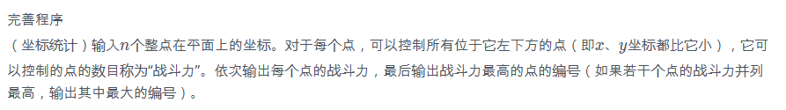
#include <iostream>
using namespace std;
const int SIZE =100;
int x[SIZE],y[SIZE],f[SIZE];
int n,i,j,max_f,ans;
int main()
{
cin>>n;
for(i=1;i<=n;i++) cin>>x[i]>>y[i];
max_f=0;
for(i=1;i<=n;i++)
{
f[i]= [ ① ];
for(j=1;j<=n;j++)
{
if(x[j]<x[i] && [ ② ])
[ ③ ] ;
}
if( [ ④ ])
{
max_f=f[i];
[ ⑤ ];
}
}
for(i=1;i<=n;i++) cout<<f[i]<<endl;
cout<<ans<<endl;
return 0;
}
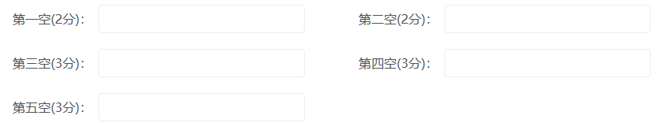
5.阅读程序写结果：
#include <iostream>
using namespace std;
int main()
{
const int SIZE = 100;
int height[SIZE], num[SIZE], n, ans;
cin>>n;
for (int i = 0; i < n; i++)
{
cin>>height[i]; num[i] = 1;
for (int j = 0; j < i; j++)
{
if ((height[j] < height[i]) && (num[j] >= num[i]))
num[i] = num[j]+1;
}
}
ans = 0;
for (int i = 0; i < n; i++)
{
if (num[i] > ans) ans = num[i];
}
cout<<ans<<endl;
}
输入：
6
2 5 3 11 12 4
输出：___________
- 如图所示，图中每条边上的数字表示该边的长度，则从A到E的最短距离是__。
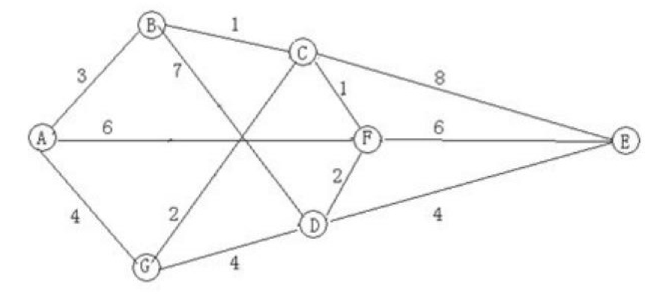

7.阅读程序写结果:
#include <stdio.h>
int main() {
int x;
scanf("%d", &x);
int res = 0;
for (int i = 0; i < x; ++i) {
if (i * i % x == 1) {
++res;
}
}
printf("%d", res);
return 0;
}
输入：15
输出：_____
8.阅读程序写结果:
#include <stdio.h>
int n, d[100];
bool v[100];

int main() {
scanf("%d", &n);
for (int i = 0; i < n; ++i) {
scanf("%d", d + i);
v[i] = false;
}
int cnt = 0;
for (int i = 0; i < n; ++i) {
if (!v[i]) {
for (int j = i; !v[j]; j = d[j]) {
v[j] = true;
}
++cnt;
}
}
printf("%d\n", cnt);
return 0;
}
输入：10 7 1 4 3 2 5 9 8 0 6
输出：__________________
- （Josephus 问题）有 n个人围成一个圈，依次标号 0 至 n−1。从 0 号开始，依次 0, 1, 0, 1, ... 交替报数，报到 1 的人会离开，直至圈中只剩下一个人。求最后剩下人的编号。
试补全模拟程序。
1 #include <stdio.h>
2
3 const int MAXN = 1000000;
4 int F[MAXN];
5
6 int main(){
7 int n;
8 scanf("%d", &n);
9 int i = 0, p = 0, c = 0;
10 while( ①){
11 if (F[i] == 0){
12 if ( ② ){
13 F[i] = 1;
14 ③;
15 }
16 ④;
17 }
18 ⑤;
19 }
20 int ans = -1;
21 for (int i = 0; i < n; i++)
22 if (F[i] == 0)
23 ans = i;
24 printf("%d\n", ans);
25 return 0;
26 }
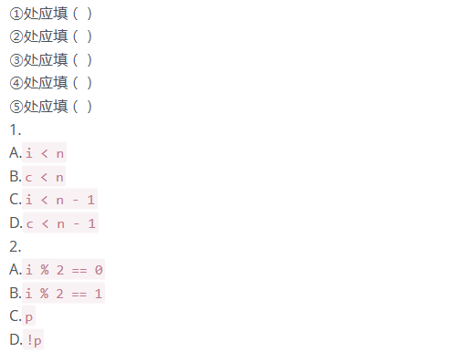
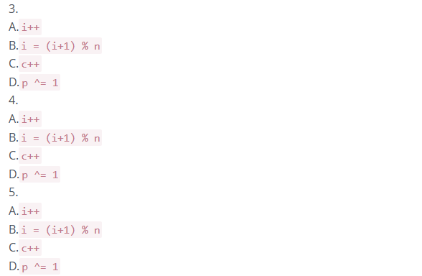

10.
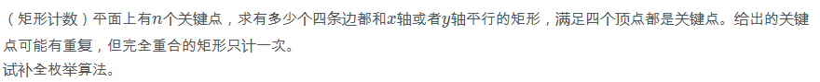
1 #include <stdio.h>
2
3 struct point {
4 int x, y, id;
5 };
6
7 int equals(struct point a, struct point b){
8 return a.x == b.x && a.y == b.y;
9 }
10
11 int cmp(struct point a, struct point b){
12 return ①;
13 }
14
15 void sort(struct point A[], int n){
16 for (int i = 0; i < n; i++)
17 for (int j = 1; j < n; j++)
18 if (cmp(A[j], A[j - 1])){
19 struct point t = A[j];
20 A[j] = A[j - 1];
21 A[j - 1] = t;
22 }
23 }
24
25 int unique(struct point A[], int n){
26 int t = 0;
27 for (int i = 0; i < n; i++)
28 if (②)
29 A[t++] = A[i];
30 return t;
31 }
32
33 int binary_search(struct point A[], int n, int x, int y){
34 struct point p;
35 p.x = x;
36 p.y = y;
37 p.id = n;
38 int a = 0, b = n - 1;
39 while(a < b){
40 int mid = ③;
41 if (④)
42 a = mid + 1;
43 else
44 b = mid;
45 }
46 return equals(A[a], p);
47 }
48
49 #define MAXN 1000
50 struct point A[MAXN];
51
52 int main(){
53 int n;
54 scanf("%d", &n);
55 for (int i = 0; i < n; i++){
56 scanf("%d %d", &A[i].x, &A[i].y);
57 A[i].id = i;
58 }
59 sort(A, n);
60 n = unique(A, n);
61 int ans = 0;
62 for (int i = 0; i < n; i++)
63 for (int j = 0; j < n; j++)
64 if ( ⑤ && binary_search(A, n, A[i].x, A[j].y) && binary_search(A, n, A[j].x, A[i].y)){
65 ans++;
66 }
67 printf("%d\n", ans);
68 return 0;
69 }
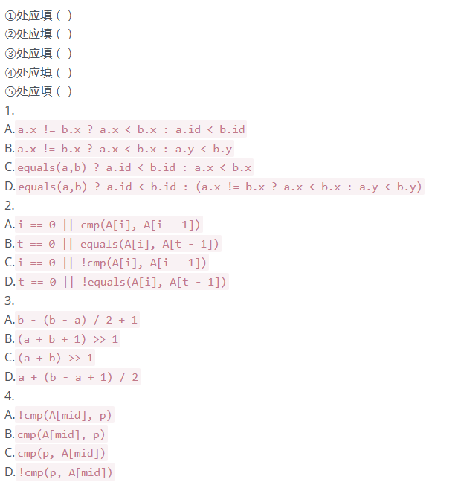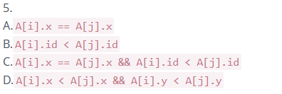



1.
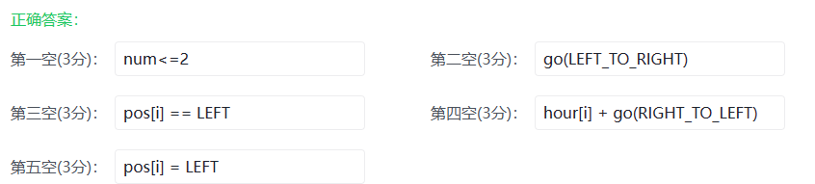
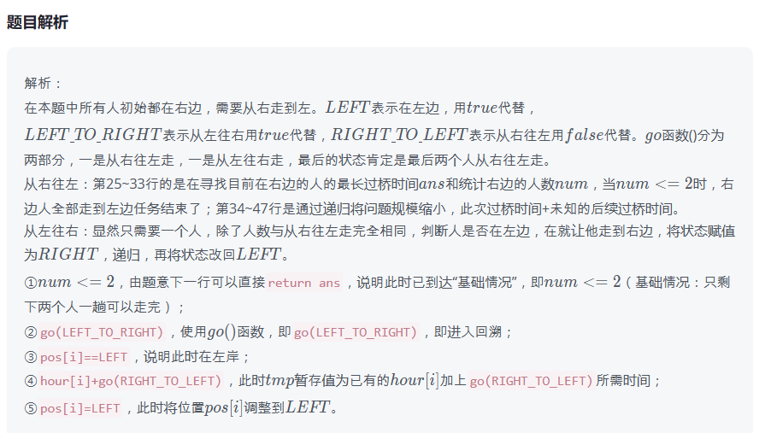
2.
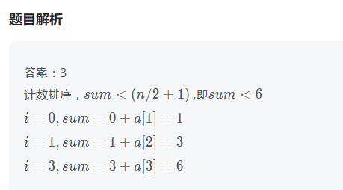
3.
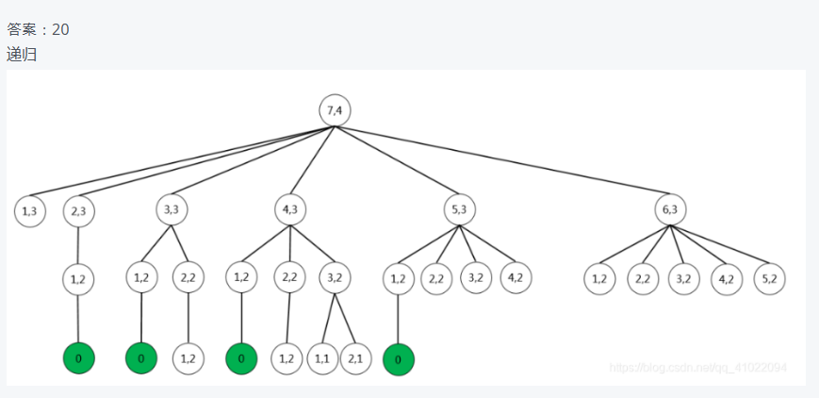
4.
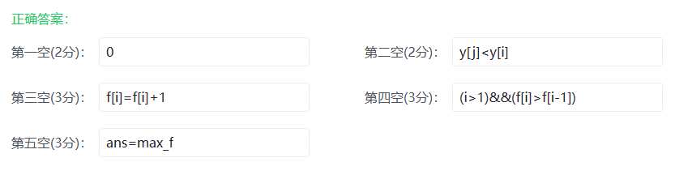
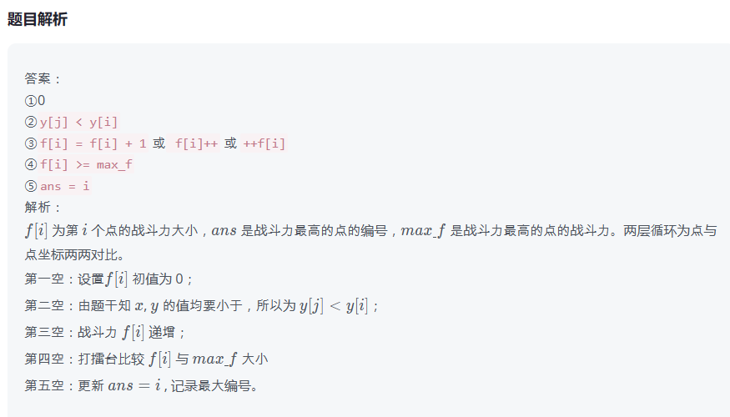

5.
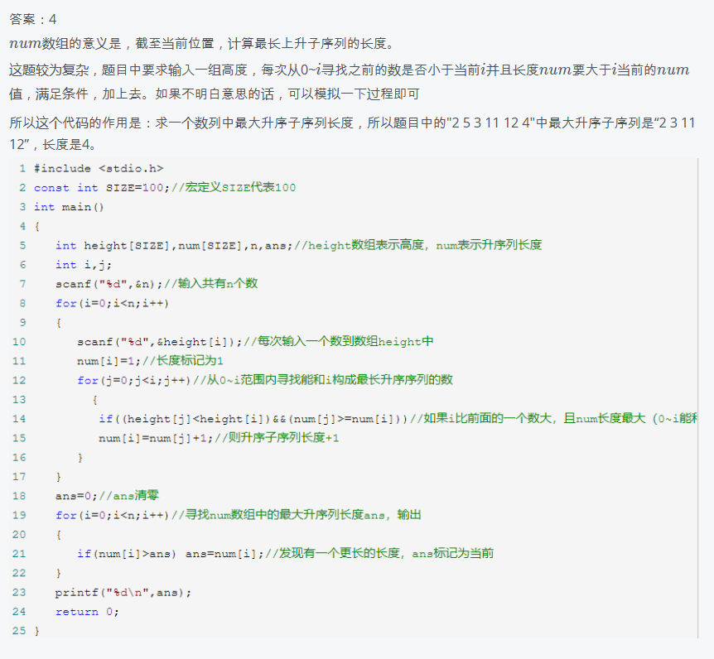
6.
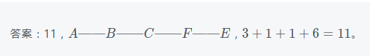
7.
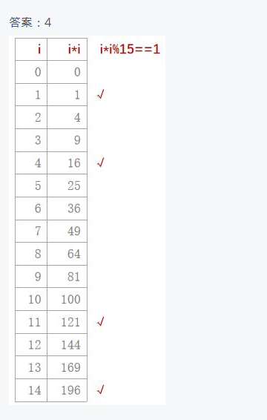
8.
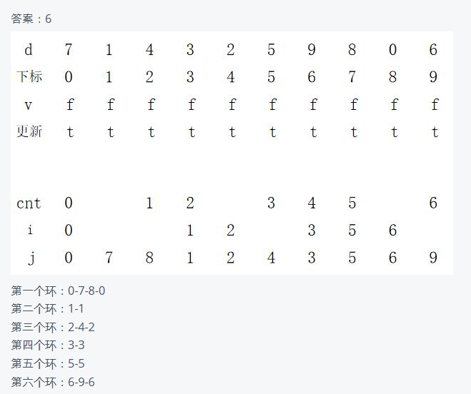
9.
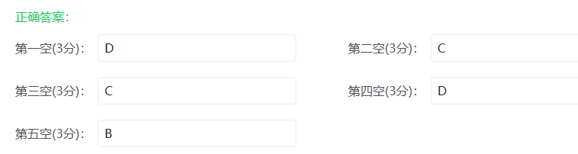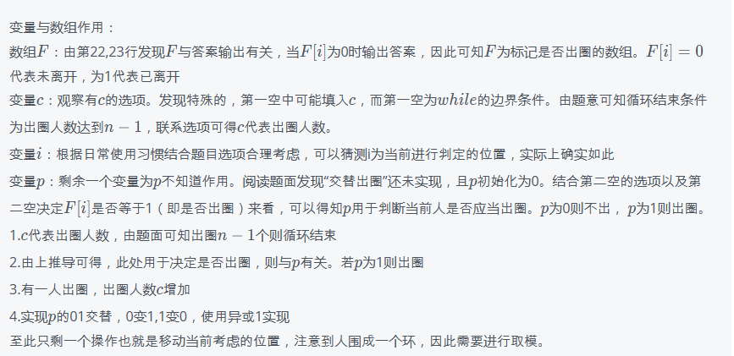
10.
